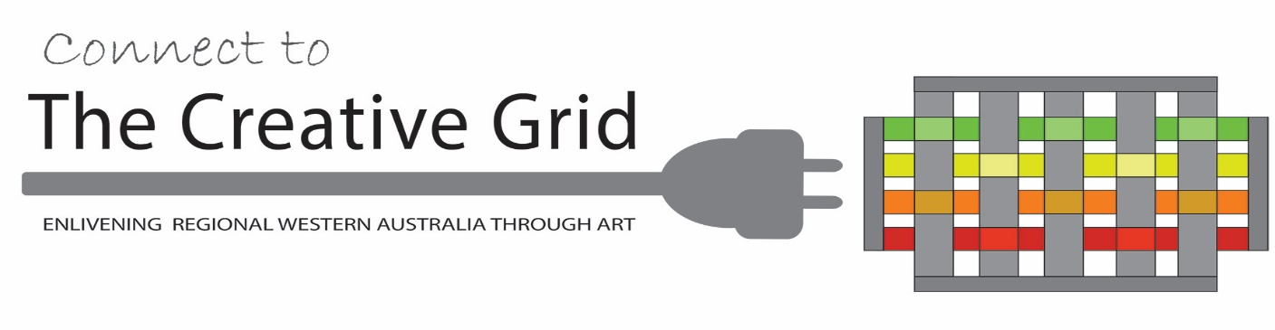

MEDIA RELEASE:

50 new mentorship opportunities available to regional WA artists, curators and photographers

FOR IMMEDIATE RELEASE

RELEASE DATE: ___mARCH 2018
State-wide regional arts initiative, The Creative Grid, announce the creation of 50 new mentorship opportunities for regional WA artists, curators and photographers
Available in 23 communities from Kunnunurra to Albany these mentorships provide a rare chance for emerging arts practitioners to receive personalised support from established professionals as they develop and strengthen their career potential.
Developed by the Creative Grid – a collaborative network of 40 regional arts organisations - the mentorship program responds to the lack of professional arts development options in the regions with each mentorship linked to the development, presentation and documentation of an ambitious series of 30 inter-connected solo and group exhibitions to be held in galleries across the State during 2018 and 2019.
Emerging Albany artist, Chelsea Hopkins Alan and her chosen Mentor, artist and former university lecturer, Paul Moncrief of Nornalup, were the first to participate in the mentorship program. Through a series of studio visits Moncrief is supporting Hopkins-Alan to develop a body of artwork for her first solo exhibition at the Vancouver Arts Centre scheduled for later this year in Albany.
Project Coordinator, Fiona Sinclair, of Southern Forest Arts in Northcliffe, says, “Mentorships can be a profoundly significant and positive influence in a creative career, particularly when distance prohibits access to other forms training. Working creatively in regional WA can be an isolating experience and mentorships help provide personal connections, linkage to new networks as well as practical skills.”
Sinclair said, “For a relatively small investment these mentorships, made possible through the Regional Arts Partnership Program, will potentially deliver big impact for participating artists, arts workers and arts organisations and communities.”
The Regional Arts Partnership Program is an initiative of the State Government of Western Australia and Country Arts WA. The Mentorship program has been supported by the Australian Government through the Regional Arts Fund.
Emerging regional artists, curators and photographers are encouraged to visit the Creative Grid Facebook page for details on which communities are offering mentorships. [ENDS]
CONTACT: PROJECT COORDINATOR: Fiona Sinclair
MOBILE: 0418 754 704 EMAIL: info@southernforestarts.com.au

READ MORE AT: http://www.southernforestarts.com.au/currentProjects.php
https://www.countryartswa.asn.au/our-services/initiatives/regional-arts-partnership-program/

PHOTO CREDIT: Green Man Media Productions

