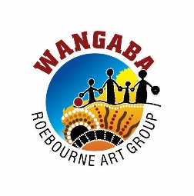

**Alternative Archive – Wangaba Exhibition**

**10th – 21st October 2019**

**Catalogue and Price List**

**Please call Lesley Murray, Manager, for enquiries and purchases on 0401299452**

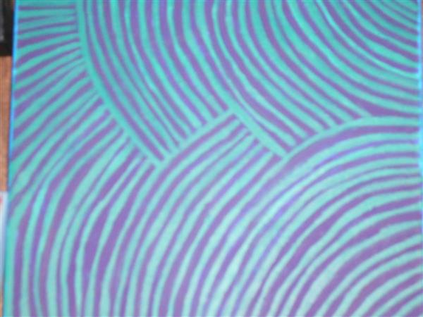**Pansy Hicks**

‘Munni Munni’

30cmx30cm

$200.00

#167-19

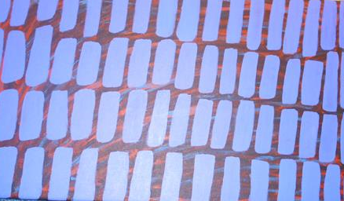

**Pansy Hicks**

“Stepping Stones’

$650.00

#182-19

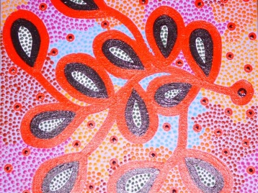**Cliff Samson**

‘Bush Medicine’

$300.00

#166-19

**SOLD**

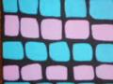**Pansy Hicks**

‘Stepping Stones’

$200.00

#165-19

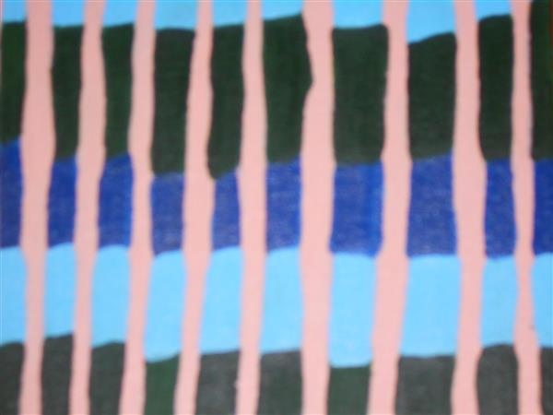

**Pansy Hicks**

‘Stepping Stones’

$200.00

#164-19

**[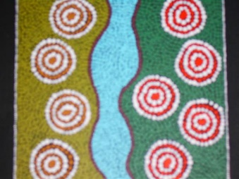](https://sam.org.au/Catalogue/ArtistArtwork.aspx?id=81845982)Kathy Samson**

‘Middens’

$250.00

#162-19

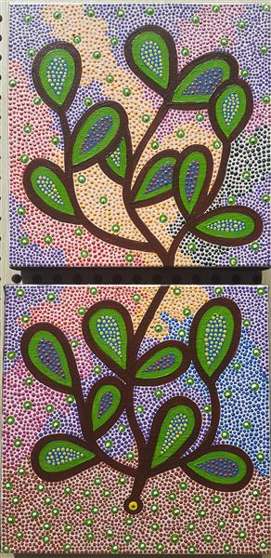**Cliff Samson**

‘Bush Medicine’

$450.00

#161-19

**SOLD**

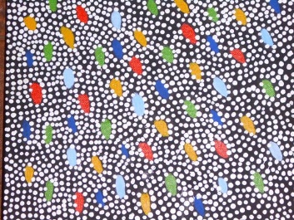**Dinah Injie**

‘Pretty Rocks’

$200.00

#158-19

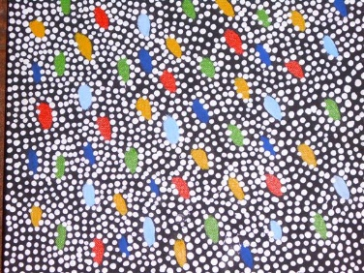**Dinah Injie**

“Pretty Rocks’

$200.00

#160-19

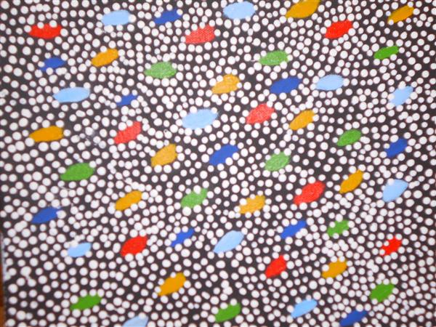**Dinah Indjie**

‘Pretty Bala-munda”

$200.00

#158-19

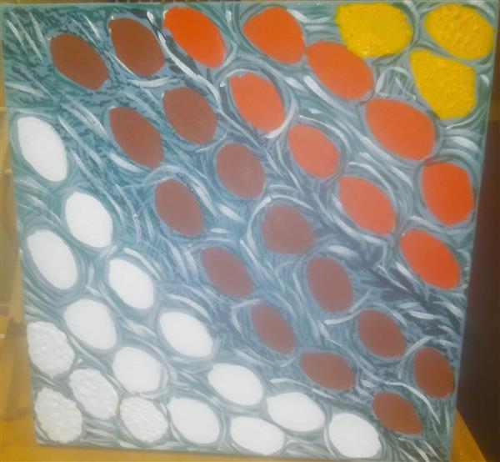

**Violet Samson**

‘Bush Seeds’

$200.00

#151-19

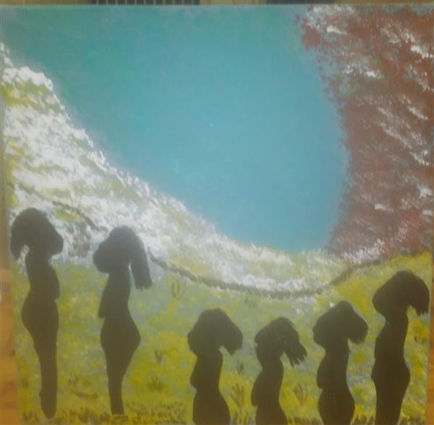**Violet Samson**

‘Women gathering

For bush tucker’

$200.00

#149-19

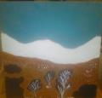**Violet Samson**

‘On the Seaside

Hunting’

$200.00

#150-19

No image exists**Telisha Samson**

‘Ngurin River’

$200.00

#119-19

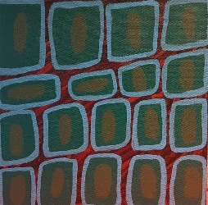**Pansy Hicks**

‘Stepping Stones’

$200.00

#118-19

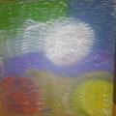

**Violet Samson**

‘Wild Flowers’

$200.00

#152-19

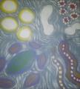

**Violet Samson**

‘Bush seeds and plants’

$150.00

#148-19

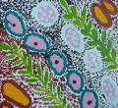**Violet Samson**

‘Bush seeds and plants’

$150.00

#110-19

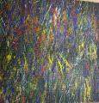

**Telisha Samson**

‘Bush Grass’

Dyptich

$300.00

#168-19

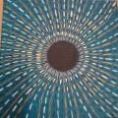**Dinah Injie**

“Jirriwi’

$150.00

#113-19

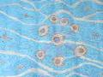**Kathy Samson**

‘Seven Sisters’

$1500.00

#178-19

**SOLD**

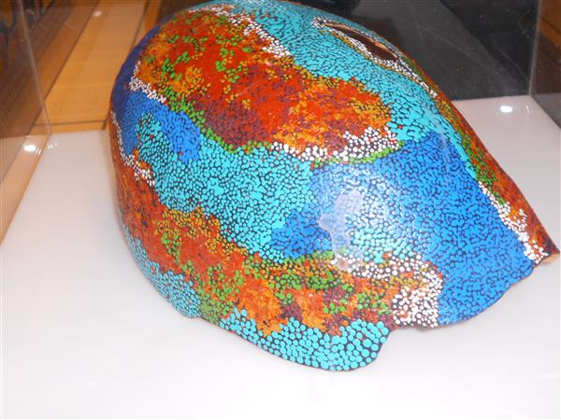**Kathy Samson**

“Ngarluma Country’

(Shell painted with acrylic

Paint) (large)

$200.00

#172-19

**SOLD**

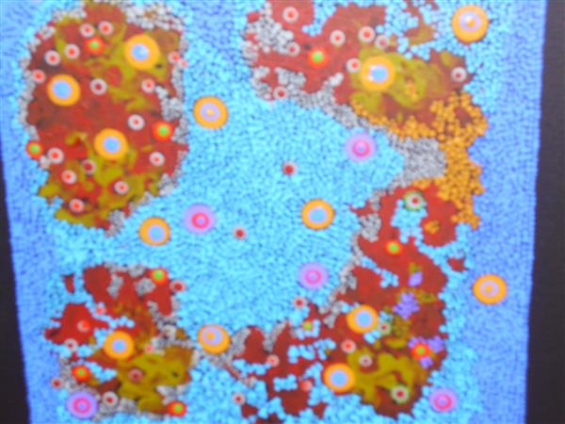

**Kathy Samson**

‘Reefs on Ngarluma Country’

$200.00

#169-19

**SOLD**

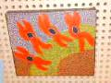**Kaylene Daniel**

‘Sturt desert pea’

$200.00

#184-19

**SOLD**

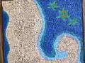**Kathy Samson**

‘Reefs”

$200.00

#79-19

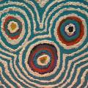

**Violet Samson**

‘Wild Flowers’

$150.00

#122-19

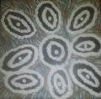**Violet Samson**

‘Bush Seeds’

$150.00

#144-19

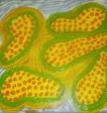**Violet Samson**

‘Bush Seeds’

$150.00

#147-19

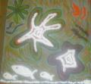**Violet Samson**

‘Bush Seeds’

$150.00

#146-19

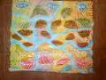

**Tootsie Daniel**

‘Bush Onions’

$900.00

#147-18

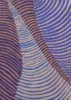

**Janine Samson**

‘Running Rivers’

$290.00

#201-15

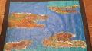**Kathy Samson**

‘Ngarluma Country’

$1000.00

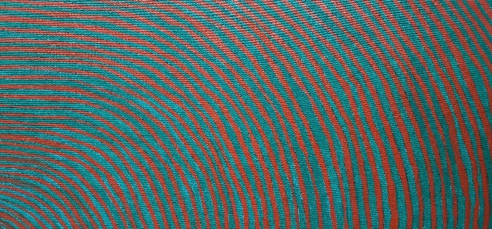#151-18

**Pansy Hicks**

‘Munni Munni Hill’

$650.00

#188-19

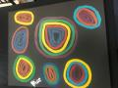**Alice Guinness – Gooru**

“Bundut’

$350.00

#156-18

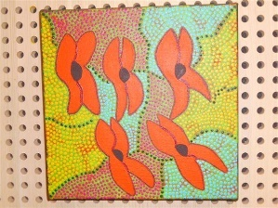**Kaylene Daniel**

‘Sturt Desert Pea’

$200.00

#178-19

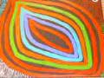**Alice Guinness - Gooru**

‘Bundut’

$550.00

#183-19

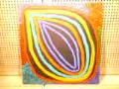**Alice Guinness – Gooru**

“Bundut’

$550.00

#182-19

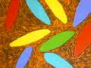

**Alice Guinness – Gooru**

‘Bijila Seeds’

$550.00

#181-19

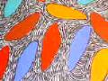**Alice Guinness – Gooru**

‘Biliji Seeds’

$550.00

#180-19

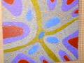**Kathy Samson**

‘Ngarluma Country

River Sands Sea’

$1000.00

#173-19

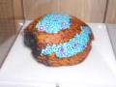**Kathy Samson**

‘Ngarluma Country on

Shell”

$150.00

#173-19

**SOLD**

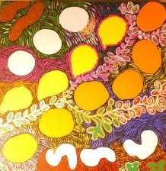**Violet Samson**

‘Bush Seeds and Plants’

$750.00

#186-19

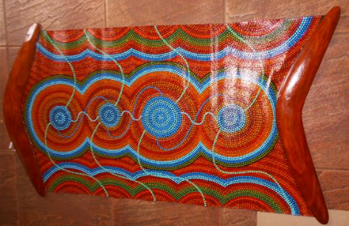**Laurie Kelly**

‘Rivers and waterholes’

$250.00

#157-19

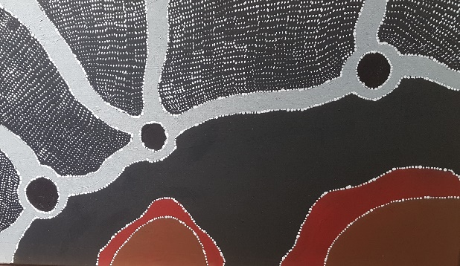

**Loreen Samson**

‘Salt Ponds’

$2000.00

#89-19

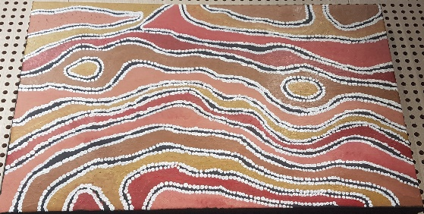**Loreen Samson**

‘Ngarluma Country’

$1000.00

#189-19

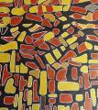

**Normie Alone**

‘Fish Trap 2”

$1200.00

#13-15

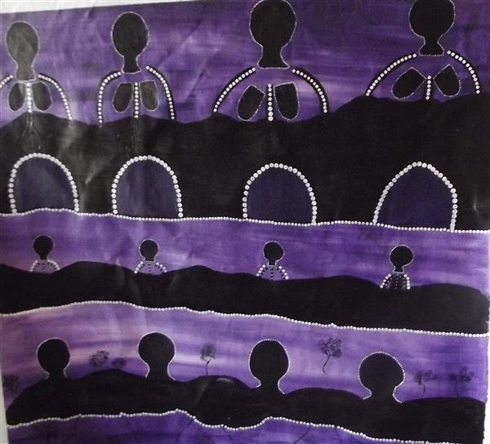

**Vanessa Punch**

‘Cultural Spirit

Women’

$950.00

#192-15

**Cliff Samson**

‘Bush Medicine’

$300.00

#166-19

**SOLD**

**[](https://sam.org.au/Catalogue/ArtistArtwork.aspx?id=81845982)Kathy Samson**

‘Middens’

$250.00

#162-19

**Kathy Samson**

‘Reefs on Ngarluma Country’

$200.00

#169-19

**SOLD**

**Pansy Hicks**

‘Stepping Stones’

$200.00

#118-19

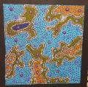**Kathy Samson**

‘Reefs on Ngarluma

Country”

$200.00

#170-19

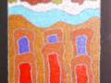**Kathy Samson**

‘Standing Stones’

$200.00

#177-19

**SOLD**

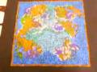

**Kathy Samson**

“Ngarluma Country’

$200.00

#91-19

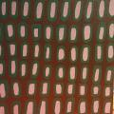

**Pansy Hicks**

‘Stepping Stones’

$200.00

#124-19

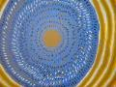**Dinah Injie**

‘Spinifex’

$350.00

#8839-11

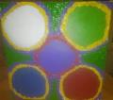**Violet Samson**

“Wild Flowers’

$150.00

#143-19

[**Amieriya Samson**](https://sam.org.au/Catalogue/artist.aspx?id=73785204)No image exists (Dolly)

‘Tribes coming together’

$300.00

#1-19

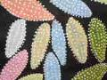

**Alice Guinness-Gooru**

“Bajila Seeds’

$450.00

#70-19

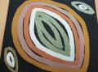**Alice Guinness-Gooru**

‘Bundut Ground’

$200.00

#115-19

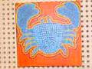**Kaylene Daniel**

‘Thadarbul (Crab)’

$200.00

#179-19